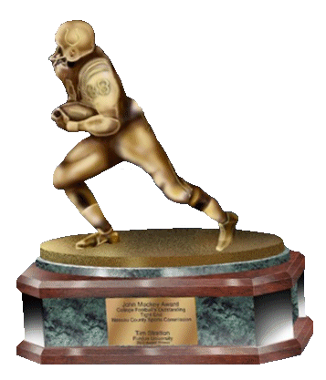

JOHN MACKEY AWARD

OUTSTANDING COLLEGIATE TIGHT END

FOR IMMEDIATE RELEASE

CONTACT: media@johnmackeyaward.com

NICK O’LEARY OF FLORIDA STATE
NAMED 2014 JOHN MACKEY AWARD RECIPIENT

New York, N.Y. (December 10, 2014) – The John Mackey Award has announced Nick O’Leary of Florida State as the 2014 John Mackey Award recipient. The John Mackey Award trophy will be presented to O’Leary on December 11th, live on ESPNU, at 6:00 pm EST on The Red Carpet Special at The Home Depot College Football Awards.
In his four years playing at Florida State, O’Leary has established a reputation for his elite blocking ability and strong receiving prowess and 2014 was another outstanding year for him. The senior recorded 47 receptions for 614 yards & seven touchdowns and his outstanding blocking helped Florida State average 34.8 points and 434.7 yards of total offense. Nick will now lead his team to the Rose Bowl and a shot at the College Football Playoff National Championship.
In addition to winning the Mackey Award, O’Leary was named a Midseason First Team All-American by Phil Steele, ESPN, Sports Illustrated, CBSSports.com and NFL.com. He has also earned First-Team All-ACC honors. O’Leary has totaled 113 receptions, 1,587 receiving yards and 17 touchdowns in his college career making him the all-time leader in receptions, receiving yards and touchdowns by a Florida State tight end and second all-time for touchdowns by a tight end in the ACC.
O’Leary marks the fifth occasion in Mackey Award history where the award recipient was a finalist the season prior. Florida State is now added to the list of schools that can boast a John Mackey Award winner but no school has won more than one John Mackey Award in the fifteen years that it has been presented.
The John Mackey Award, celebrating its 15th anniversary, is given to the collegiate tight end who best exemplifies the play, sportsmanship, academics, and community values of NFL Hall of Fame Tight End John Mackey. The 2014 John Mackey Award recipient was determined by confidential balloting of the John Mackey Selection Committee.

The John Mackey Award lists thirteen alumni to have played in the NFL: two-time Super Bowl Champion Daniel Graham (‘01), 2006 Super Bowl Champion Dallas Clark (‘02), Kellen Winslow II (‘03), two-time Super Bowl Champion Heath Miller (‘04) of the Pittsburgh Steelers, Marcedes Lewis (‘05) of the Jacksonville Jaguars, 2008 Super Bowl Champion Matt Spaeth (‘06) of the Pittsburgh Steelers, Fred Davis (‘07), Chase Coffman (‘08) of the Tennessee Titans, Aaron Hernandez (‘09), D.J. Williams (‘10), Dwayne Allen (’11) of the Indianapolis Colts, Tyler Eifert (’12) of the Cincinnati Bengals and Austin Seferian-Jenkins (’13) of the Tampa Bay Buccaneers.

The John Mackey Award is a member of the National College Football Awards Association (NCFAA) which encompasses the most prestigious awards in college football. The 21 awards boast 678 years of tradition-selection excellence. Visit www.NCFAA.org to learn more about our story.
The Friends of John Mackey is responsible for the administration of the John Mackey Award and the Mackey Selection Committee. Visit www.johnmackeyaward.com for all Mackey Award information.

